CAPE
RPA Development Skill
AI-Assisted RPA Development Knowledge and Productivity Enhancement

Introduction

RPA Context at Inchcape
Inchcape's Robotic Process Automation (RPA) ecosystem operates within a multi-platform, cost-conscious framework engineered to deploy the optimal automation tool based on process complexity, volume, and strategic requirements. The current architecture leverages four core pillars: AutoDrive, Power Automate Cloud, UiPath, and Azure AI Foundry / Databricks.
- AutoDrive: The team's in-house Python-based automation framework, representing the default technology choice for new automation initiatives. It advanced libraries such as PyAutoGUI, pywin32, Selenium, and OpenCV to orchestrate user-interface automation and complex data-processing workflows.
- Power Automate Cloud: Utilized primarily to streamline automation within the Microsoft ecosystem, specifically targeting workloads centered around SharePoint, Microsoft Forms, and Teams.
- UiPath: Reserved for high-complexity enterprise scenarios that exceed the scope of the in-house framework, particularly processes demanding multi-application integration, persistent state management, or enterprise-grade orchestration.
- Azure AI Foundry and Databricks: Powering advanced artificial intelligence and machine learning use cases, with a strategic focus on Intelligent Document Processing (IDP).
While this multi-faceted architecture equips the RPA team to navigate diverse automation demands, it also requires developers to master the specific capabilities, boundaries, and best practices of multiple platforms, rather than relying on a single technology stack.
To manage this technical complexity, Inchcape enforces a rigorous RPA delivery lifecycle that governs automation initiatives from inception to continuous operations. Underpinned by the Project Intake Framework, this lifecycle dictates ten sequential phases:
- Request & Approval
- Discovery & Scoping
- Project Documentation
- Architecture Review
- Development
- User Acceptance Testing (UAT)
- Internal Change Advisory Board (CAB) Review
- Global Change Advisory Board (CAB) Review
- Deployment
- Hypercare & Business-as-Usual (BAU) Handover
Consequently, successful RPA delivery extends far beyond the technical execution of a task. Effective development is intrinsically tied to a engineer's ability to navigate organizational governance, encompassing security, access management, comprehensive testing, meticulous documentation, change management, and strict compliance controls throughout the entire lifecycle.

The RPA Knowledge Environment
To support this complex technical and operational framework, the RPA team has cultivated a comprehensive, institutional knowledge base over time. Centralized primarily within the team’s Confluence spaces, this repository encapsulates critical operational dimensions, including RPA strategy and architecture, service definitions, development standards, and data governance. It also codifies security guidelines, access procedures, CAPTCHA/MFA policies, critical-incident management, change management protocol, solution documentation, and role-specific definitions. This structured knowledge is further enriched by Service Desk telemetry, which injects real-time operational insights from ongoing incidents and support activities into the core documentation ecosystem.
While this vast information ecosystem represents a vital organizational asset, its mere existence does not guarantee frictionless accessibility. When developers encounter complex technical or procedural challenges, retrieving the correct solution typically requires searching across disparate documents, validating the currency of the source, and translating theoretical guidelines into the context of an active automation. When ambiguity persists, developers must pivot to peer consultation. This information-retrieval friction occurs even during routine operations, particularly regarding:
- Development Standards: Coding best practices and architecture compliance.
- Platform Selection: Technology evaluation and pipeline validation.
- Security & Access: Credential provisioning and compliance requirements.
- Troubleshooting: Active debugging and root-cause analysis.
- Integration Protocols: API management and system connectivity.
- Quality Assurance: Testing execution and code-review metrics.
- Governance Frameworks: Documentation standards and change control.
- Change Management: CAB approval preparation and deployment readiness.
- Operational Resilience: Incident handling and business continuity procedures.

Crucially, this operational drag stems not from an information deficit, but from an accessibility bottleneck. The necessary expertise already resides within the organization's legacy documentation and collective team experience; the true challenge lies in efficiently isolating, contextualizing, and applying that knowledge at the exact moment of execution. Recognizing this distinction shifts the strategic imperative: the objective is not to build another fragmented information repository, but to revolutionize how existing organizational intelligence is accessed, consumed, and operationalized.

CAPE as an Opportunity for Knowledge Accessibility
This strategic opportunity stems from the operational deployment of CAPE (Capability Accelerator Productivity Engine) and from observing how its existing capabilities could be applied to the RPA development environment. CAPE delivers a mature, AI-enabled ecosystem featuring reusable Skills and native integrations with core corporate repositories, including Confluence and read-only Service Desk telemetry. By exploiting this Skill-based framework, specialized domain intelligence and behavioral guardrails can be injected dynamically into user interactions, creating a compelling pathway to extend CAPE beyond general-purpose automation and toward highly specialized, team-centric applications.
For the RPA division, this approach bypasses the need to introduce redundant platforms, disparate databases, or siloed AI assistants. Instead, a tailored engineering asset can be engineered directly within an existing corporate utility. The proposed RPA Development Skill functions as an intelligent knowledge and productivity layer superimposed on the existing ecosystem, empowering engineers to interact with corporate documentation via an intuitive, context-aware interface. This conceptual alignment is mapped in Figure 1.
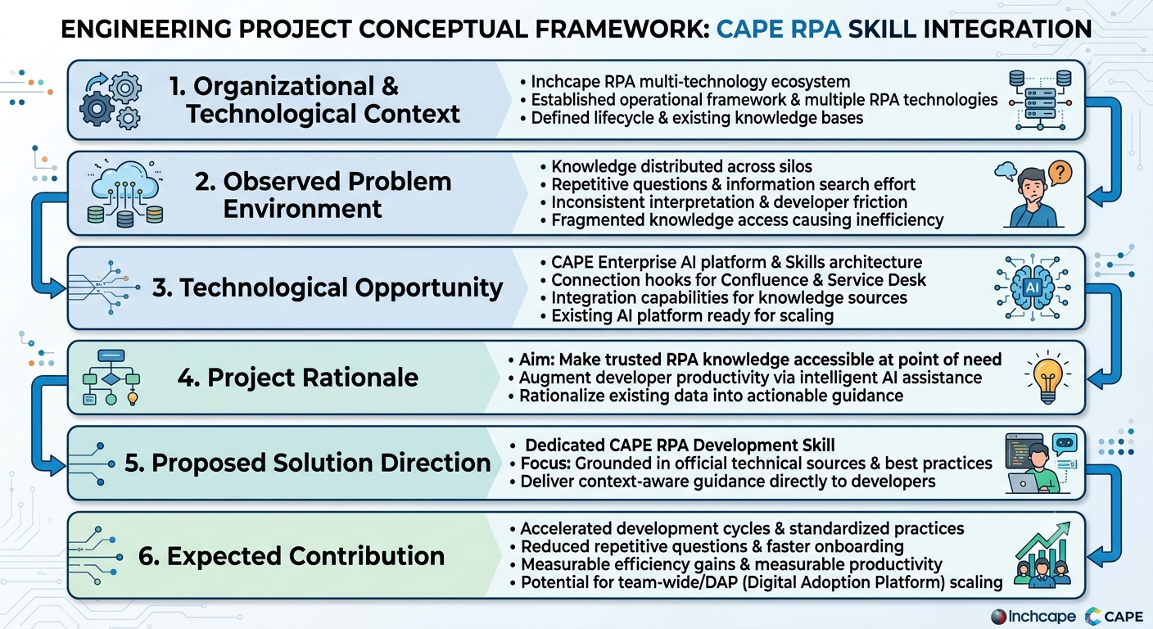
Figure 1. Conceptual Framework for the CAPE RPA Development Skill Initiative

Crucially, the scope of this Skill must be precisely bounded. It is not engineered to supplant Confluence as the golden source of documentation, replace the Service Desk as an operational system, bypass senior developers as sources of expertise, or circumvent formal governance processes such as architecture reviews, security validation, and CAB approvals. Rather, its purpose is to augment how engineers extract and operationalize underlying intelligence, minimizing time-to-insight while maintaining the absolute authority of established workflows and governance frameworks.
Ultimately, while CAPE establishes the core technological foundation, the RPA Development Skill delivers the specialized domain knowledge, contextual insight, and behavioral guidance required to transform that framework into a practical, high-impact development capability.

From Knowledge Accessibility to Developer Productivity
The strategic value of optimizing knowledge accessibility rests on its capacity to fundamentally transform developer workflows. By empowering engineers to extract precise, verified guidance instantly, without enduring repetitive search loops or creating peer-to-peer bottlenecks, valuable cycles are reclaimed. This newly recovered capacity can be directly reallocated to high-value activities such as implementation, debugging, core testing, and accelerated delivery. Concurrently, by grounding all responses in Inchcape’s established RPA standards, the organization can mitigate structural variance in how technical challenges are interpreted and executed. This creates a direct, causal link between accelerated knowledge access and operational consistency across the development lifecycle.
This relationship defines the core thesis of this initiative:
“Frictionless access to contextualized, enterprise-validated knowledge directly drives developer efficiency, architectural alignment, and engineering consistency.”
Consequently, this initiative does not seek to deploy an AI assistant merely for the sake of technological novelty. To deliver true utility, the RPA Development Skill must target active, day-to-day engineering bottlenecks with highly actionable guidance. Its outputs must be hyper-relevant to the developer’s active prompt, rigorously aligned with Inchcape’s governance frameworks, technically verified by authoritative sources, and prescriptive enough to guide the next development step.
Equally critical is the Skill’s adherence to intellectual boundaries. When encountering incomplete, conflicting, or ambiguous source data, the system must explicitly declare its operational limits rather than hallucinating an unsupported resolution with unwarranted confidence.
Ultimately, this paradigm highlights the critical distinction between knowledge availability and knowledge usability. The RPA division already possesses the institutional intelligence required to solve complex engineering challenges. However, when the extraction of that intelligence demands extensive manual searching, manual interpretation, or interpersonal consultation, the value of that knowledge is severely degraded. This initiative bridges that operational chasm, converting static organizational documentation into a dynamic catalyst for developer velocity.

Proposed Initiative
To capitalize on this architectural opportunity, the foundational initiative proposed within the CAPE framework is the engineering of a dedicated RPA Development Skill. Rather than distributing resources across multiple concurrent automation tracks, this project prioritizes a singular, well-defined use case. This phased approach establishes an optimized baseline of system behavior, validates performance metrics, and substantiates quantifiable business value prior to scaling the framework across the enterprise. By constraining the initial scope, the initiative remains operationally agile while generating empirical evidence to de-risk future strategic expansions.
Core Functional Scope
The Skill will be architected around the precise technical dimensions and activities that govern an engineer's daily workflow. To optimize clarity and utility, its primary operational scope is classified into twelve core pillars:
- Architectural & Platform Decisions: Evaluative guidance on multi-platform selection, system constraints, architectural alignment, and optimal solution design across Inchcape’s supported technology stack.
- Development Standards & Patterns: Implementation of approved coding conventions, maintainability guardrails, clean-code practices, and enterprise engineering standards tailored for RPA.
- Advanced Troubleshooting: Structured diagnostic methodologies for system error interpretation, root-cause isolation, and targeted technical remediation strategies.
- Integration & API Management: Technical blueprints for orchestrating secure connections between RPA workflows and external applications, legacy systems, APIs, and enterprise databases.
- Quality Assurance & Testing: Robust validation strategies, automated testing execution, and peer-review considerations to safeguard automation reliability and minimize technical debt.
- Observability & Exception Handling: Standardized logging frameworks, proactive error-trapping paradigms, diagnostic telemetry, and operational resilience mechanisms.
- Security & Credential Governance: Compliant authentication protocols, secure credential vaulting, data-masking rules, and strict adherence to enterprise security controls.
- Lifecycle Governance & Documentation: Standardized documentation templates, solution design definitions, gatekeeper requirements, and organizational compliance benchmarks.
- Change Control & Deployment Operations: Tactical navigation of CAB approvals, continuous integration/continuous deployment (CI/CD) pipelines, hypercare management, and formalized BAU transitions.
- Incident Resolution & Support Telemetry: Real-time interpretation of Service Desk ticket trends, incident-handling workflows, and support workflows derived from active system telemetry.
- Institutional Documentation Translation: Context-aware interpretation and semantic searching of Inchcape-specific wikis, internal policies, and historical team knowledge bases.
- Technology-Specific Engineering Guidance: Deep-dive technical assistance regarding core developer frameworks, native libraries (e.g., Selenium, OpenCV, pywin32), and proprietary vendor features.

Scope Management & Guardrails
These twelve pillars define an initial operational baseline rather than an inflexible boundary. The definitive scope will continuously adapt based on active developer telemetry—specifically targeting recurring technical friction points, high-frequency knowledge-search loops, and complex delivery scenarios where the Skill provides a demonstrable efficiency dividend. The overarching objective remains clear: to develop a highly concentrated utility tailored around high-velocity access, not an exhaustive encyclopedia of general RPA theory.
Consequently, the Skill will not attempt to resolve speculative or extraneous technical queries merely because the underlying LLM capability permits it. System utility is intrinsically linked to maintaining strict context boundaries. If a user query falls outside the Skill’s validated data perimeter or breaches corporate policy, the mandated guardrail behavior will be triggered: the system will explicitly declare its operational limitation, prompt for necessary context, seamlessly redirect the engineer to the official golden source, or recommend escalating through established human-in-the-loop channels.
Knowledge Hierarchy & Authoritative Sources
To maintain absolute data integrity, the underlying knowledge ecosystem will adhere to a rigorous hierarchy of relevance and authority. Internal Inchcape Documentation commands absolute precedence for all corporate policies, governance frameworks, and localized processes. Concurrently, Official Vendor Documentation serves as the authoritative source for technology-specific, deep-technical architecture. Where broader engineering paradigms are required, validated Industry Frameworks and Academic Literature will be synthesized to provide theoretical foundation. The granular governance strategy—encompassing source ingestion, validation matrices, prioritization logic, data freshness, and long-term asset maintenance—is detailed later in this blueprint.

Initial Project Direction
The strategic trajectory of this initiative is anchored to a highly focused, high-impact objective: the RPA Development Skill must demonstrably accelerate developer velocity while enforcing architectural consistency. This core mandate derives directly from the operational challenges identified across the lifecycle and serves as the ultimate benchmark for all downstream engineering decisions. Consequently, any new feature, source integration, or system behavior must be evaluated strictly against its contribution to this objective, purposefully avoiding feature creep or technological sophistication for its own sake.
Strategic Execution Framework
To operationalize this direction, the initial development lifecycle will follow a structured, four-phase execution loop:
- Identify: Isolate high-frequency queries/questions, knowledge-retrieval bottlenecks, and engineering friction points where context-aware AI assistance can deliver immediate, meaningful value.
- Design: define the Skill’s semantic knowledge architecture, authoritative source hierarchy, contextual response behaviors, and strict operational guardrails based on real-world developer workflows.
- Build & Test: develop a functional, high-fidelity iteration of the Skill and rigorously evaluate its outputs against representative RPA production scenarios and developer prompts.
- Measure & Refine: Quantify system performance across technical accuracy, contextual trust, and efficiency gains to drive continuous, data-driven optimization loops.

Validation Pillars
Validating this initial capability requires translating the core objective into observable, auditable outcomes. The project's success will be continuously monitored across six operational vectors:
- Efficiency: Does the Skill systematically reduce the time developers spend searching for relevant information?
- Repetition: Does it reduce the volume of repetitive and redundant questions that are repeatedly directed toward experienced team members?
- Consistency: Does it deliver consistent and aligned guidance when developers encounter recurring or equivalent technical challenges?
- Governance Compliance: Does it faultlessly enforce established Inchcape RPA standards, security protocols, and change-management procedures?
- Workflow Trust: Do developers actively recognize the responses as accurate, actionable, and dependable enough to embed into daily production tasks?
- Productivity value: Does sustained interaction and use with the Skill demonstrate a measurable improvement in the efficiency of relevant development activities?
These validation vectors establish high-level strategic requirements without prematurely locking in a rigid testing methodology. A granular evaluation framework—detailing baseline benchmarks, automated test suites, scoring rubrics, and acceptance thresholds—is defined later in this document.
Evidence-Driven Progression
Ultimately, this initiative is explicitly designed to be evidence-driven rather than feature-driven. The deployment of a functional Skill does not, by itself, represent a milestone of success. Instead, the framework must prove an empirical performance premium over legacy knowledge-retrieval methods. Success metrics will focus heavily on reducing information-seeking cycles and reinforcing technical uniformity, as these directly translate to organizational velocity.
If this initial phase hits its performance thresholds, the project will transition into system hardening and formal operational integration. Broader expansion, including the development of secondary RPA-related Skills or enterprise scaling across DAP, will remain strictly gated until this first benchmark is achieved. This gated governance strategy eliminates early scope risk while charting a clear, value-backed path from proof of concept to full organizational scaling, as mapped in Figure 2.
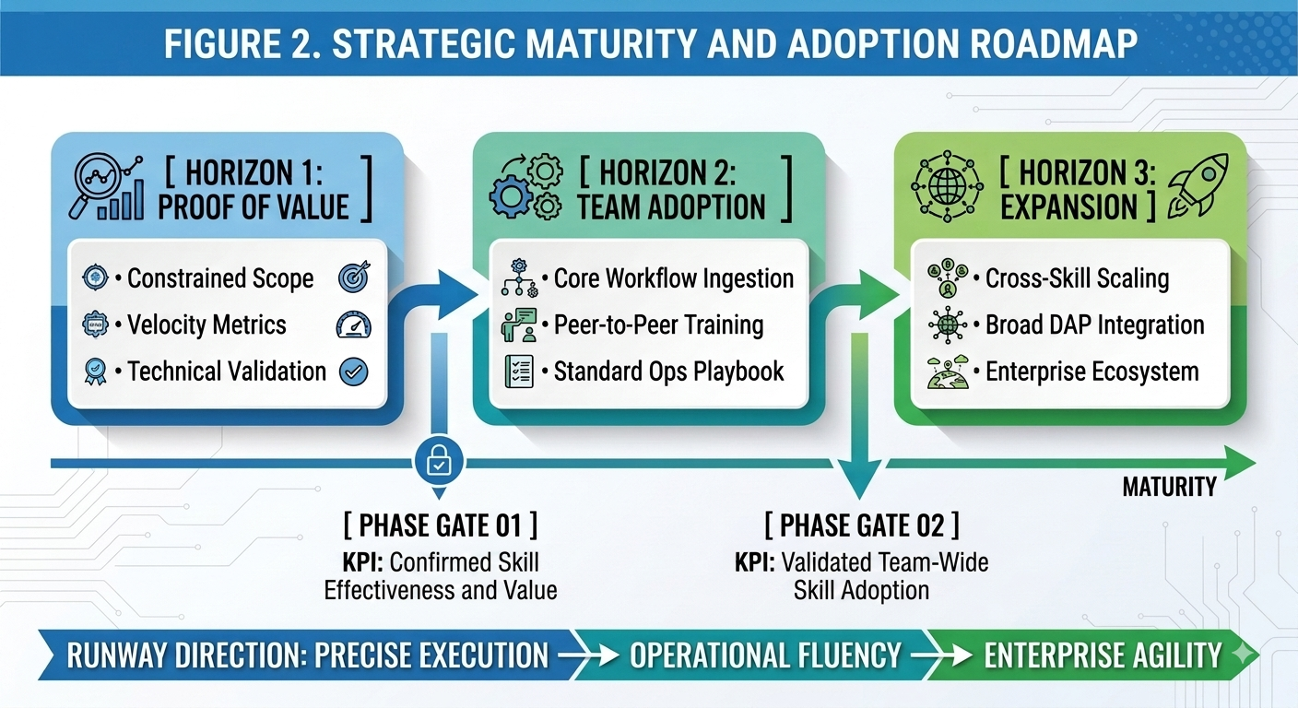
Figure 2. Strategic Maturity and Adoption Roadmap for the RPA Development Skill

Document Purpose
This document establishes the comprehensive strategic, technical, and operational architecture required to design, engineer, evaluate, and adopt the CAPE RPA Development Skill. It functions as a definitive engineering roadmap, codifying the underlying business justification, the operational bottlenecks targeted, the benchmarks defining success, and the rigorous testing methodology engineered to validate system performance.
Critically, this document is a living framework designed to evolve synchronously with the initiative. As the Skill undergoes active research, sandbox deployment, and performance hardening, this repository will continuously ingest architectural decisions, empirical telemetry, historical edge cases, and cross-iteration optimizations. Consequently, it serves a dual purpose: a practical execution playbook for the engineering team, and an authoritative record documenting how a conceptual prototype is systematically hardened into an enterprise-ready utility.
The Core Value Progression
The architecture of this initiative follows a highly logical, four-stage value progression:
- Stage 1 - Institutional Intelligence: Inchcape’s automation ecosystem possesses an extensive, highly valuable repository of technical and process knowledge accumulated across legacy platforms and collective engineering expertise.
- Stage 2 - Developer Execution Needs: Engineers must seamlessly extract and weaponize this institutional intelligence throughout the automation delivery lifecycle, typically under time-critical operational pressures.
- Stage 3 - Technological Catalyst: CAPE provides an established, AI-native infrastructure to abstract away documentation complexity, transforming static corporate wikis into context-aware, hyper-efficient guidance.
- Stage 4 - Targeted Performance Output: The RPA Development Skill serves as the controlled vehicle to prove whether this technological bridge drives quantifiable gains in developer velocity and code consistency.
Document Roadmap
The remainder of this document operationalizes this core thesis into a concrete, auditable, and scalable technical implementation strategy. Subsequent chapters systematically transition from problem classification and KPI definitions into detailed deep dives covering the Skill’s data ingestion strategy, behavioral guardrail engineering, system deployment mechanics, pilot phase parameters, and enterprise-wide adoption criteria.

Problem Definition and Current State

2.1 Current Knowledge-Access Model

2.2 Developer Information-Seeking Process

2.3 Identified Pain Points

2.4 Root Causes

2.5 Impact on Developer Efficiency and Consistency

2.6 Problem Statement

2.7 Opportunity Statement

2.8 Project Scope and Boundaries

3. Justification and Opportunity

4. Vision
To establish CAPE as an intelligent technical knowledge companion for the RPA team, enabling developers to access trusted organizational and industry knowledge at the point of need and apply consistent, high-quality engineering practices throughout the automation lifecycle.

5. Mission
To develop and continuously improve a specialized RPA Development Skill that consolidates trusted technical knowledge, organizational standards, development practices, and contextual guidance into an accessible AI-assisted capability that helps RPA developers make faster, more consistent, and better-informed technical decisions.

6. Objectives

6.1 General Objective
Design, develop, and validate a specialized RPA Development Skill within CAPE that improves the efficiency, consistency, and accessibility of technical knowledge for RPA developers through the integration of trusted organizational and external technical knowledge sources.

6.2 Specific Objectives
- Identify, classify, and structure the internal RPA knowledge required to support the team's most frequent development and technical activities.

7. Scope

7.1 In Scope
- RPA development guidance across the team's supported automation technologies.
- Internal RPA standards, architecture, governance, security, documentation, and lifecycle guidance.
- Trusted external technical documentation and standards relevant to supported technologies and engineering practices.
- Architecture and technology-selection guidance within the boundaries of established organizational strategy.
- Development, debugging, testing, documentation, code-quality, and maintainability guidance.
- Evaluation of response quality, consistency, usability, and developer-efficiency impact.
- Controlled pilot implementation and iterative refinement.

7.2 Out of Scope
- Replacing formal architecture, security, CAB, or other organizational approval processes.
- Autonomous production deployment or modification of production systems.
- Automatic creation or modification of Service Desk tickets in the initial scope.
- Replacing human technical ownership or accountability.
- Attempting to provide unrestricted expertise on every possible technology or business process.

7.3 Future Scope
Potential future extensions may include specialized Skills for RPA code review, solution design, troubleshooting, testing, documentation, process assessment, architecture advisory, and onboarding. These capabilities will be considered only after the initial RPA Development Skill has demonstrated measurable value.

8. Stakeholders and Target Users
Stakeholder / User | Role in Initiative
Nikko | Project sponsor; provides strategic direction, challenge, and review.
Juan José Restrepo | Project lead; responsible for discovery, design, implementation, evaluation, and reporting.
Isa | Key stakeholder; kept informed throughout development and pilot activities.
RPA Developers | Primary users and participants in pilot validation.
RPA Technical Leads / Architecture | Potential reviewers of technical recommendations and standards.
CAPE / DAP stakeholders | Potential stakeholders for future wider adoption.

9. Current-State Analysis

9.1 RPA Technology Landscape
Technology | Primary Role | Strategic Position
AutoDrive | In-house Python framework using PyAutoGUI, pywin32, Selenium, OpenCV, and related capabilities. | Default / first choice
Power Automate Cloud | Microsoft ecosystem automation including SharePoint, Forms, and Teams workloads. | Preferred for Microsoft workloads
UiPath | Enterprise RPA for complex, multi-system processes. | Used when justified by technical requirements and licensing considerations
Azure AI Foundry / Databricks | AI/ML layer for intelligent document processing and related capabilities. | AI/ML layer

9.2 RPA Development Lifecycle
- Request & Approval
- Discovery & Scoping
- Project Repository Documentation
- Architecture Review & Kickoff
- Development
- UAT
- Internal CAB (Pre-CAB)
- Global CAB (Production CAB)
- Deployment
- Hypercare & BAU Handover

9.3 Existing Knowledge Ecosystem
- RPA Service Definition and service architecture documentation.
- RPA Strategy and platform-selection guidance.
- RPA Project Intake Framework.
- RPA Architecture overview.
- UiPath and Power Automate best-practice documentation.
- UiPath security guidelines and access procedures.
- CAPTCHA/MFA policy.
- Critical Incident framework and playbooks.
- RPA Data Policy.
- Change Management guidance.
- Solution documentation and active/BAU project repositories.
- Role and job-description documentation.
- SAP Robot User Policy.

9.4 Current Pain Points
- Access and credential-management questions.
- Technology-selection and architecture decisions.
- CAB and change-management requirements.
- Incident classification, escalation, and troubleshooting.
- CAPTCHA/MFA-related manual interventions.
- Knowledge-transfer gaps.
- Documentation and governance rework.
- Infrastructure and VM provisioning delays.
- External system/API limitations requiring workarounds.

9.5 Current Knowledge and Process Gaps
The initial assessment indicates that the principal opportunity is to improve knowledge accessibility and contextualization rather than simply increasing the amount of documentation. The Skill should therefore prioritize high-frequency, high-friction developer questions and provide guidance that connects technical recommendations to the organization's established processes and standards.

10. Proposed Solution

10.1 Solution Overview
The proposed solution is a domain-specific CAPE Skill focused on RPA development. The Skill will operate as an intelligent technical assistant that interprets developer requests, identifies the relevant RPA domain and project context, retrieves or applies appropriate organizational knowledge, and produces actionable guidance.
The solution will be designed around the principle that trusted internal knowledge and approved organizational standards should take precedence over generic recommendations when the two conflict.

10.2 Expected Capabilities
- RPA technology and architecture guidance.
- Development best practices and coding standards.
- Debugging and troubleshooting support.
- API and integration guidance.
- Testing and quality guidance.
- Documentation and maintainability support.
- Security and credential-management guidance.
- Governance, CAB, and lifecycle guidance.
- Technology-selection support within the established RPA strategy.
- Contextual explanation of internal RPA documentation.

10.3 Expected Developer Experience
The intended experience is conversational and task-oriented. Developers should be able to describe a technical problem or development question in natural language and receive a concise, actionable response that is aligned with the RPA team's standards and technology landscape.
Where the available evidence is insufficient, the Skill should explicitly communicate uncertainty, identify missing information, and recommend the appropriate internal documentation or human owner rather than inventing an answer.

10.4 Expected Business Value
- Reduced time spent searching for technical information.
- Reduced repetition of common technical questions.
- More consistent application of internal development standards.
- Improved knowledge transfer and onboarding.
- Faster identification of appropriate technical approaches.
- Increased adoption and demonstrated value of CAPE within the RPA team.

11. Initial Functional Requirements
ID | Requirement
FR-001 | The Skill shall provide RPA development guidance across the technology platforms supported by the team.
FR-002 | The Skill shall prioritize approved internal RPA standards and documentation for organization-specific questions.
FR-003 | The Skill shall use authoritative external technical sources where internal documentation is insufficient.
FR-004 | The Skill shall distinguish organizational requirements from general industry recommendations.
FR-005 | The Skill shall identify uncertainty or insufficient context rather than fabricate technical information.
FR-006 | The Skill shall support common development, debugging, architecture, documentation, security, and governance questions.
FR-007 | The Skill shall be evaluated using a defined test set representing realistic RPA developer questions.
FR-008 | The Skill shall support iterative improvement based on pilot feedback and evaluation results.

12. Initial Non-Functional Requirements
- Accuracy: recommendations should be technically correct and aligned with authoritative sources.
- Consistency: materially equivalent questions should produce materially consistent guidance.
- Traceability: source context should be identifiable whenever the CAPE implementation supports source attribution.
- Maintainability: knowledge and instructions should be structured so they can be updated independently.
- Security: the Skill must not encourage insecure credential handling, unauthorized access, or bypassing organizational controls.
- Usability: responses should be understandable and actionable for RPA developers with different levels of experience.
- Efficiency: the Skill should reduce, rather than increase, the effort required to resolve routine technical questions.

13. Knowledge Engineering Strategy

13.1 Initial Knowledge Domains
- RPA strategy and platform selection.
- RPA architecture.
- AutoDrive development practices.
- UiPath development practices.
- Power Automate development practices.
- Python and general software engineering practices.
- APIs and integrations.
- Testing and quality assurance.
- Logging and exception handling.
- Security and credential management.
- Documentation standards.
- CAB and change management.
- Incident management.

13.2 Source Categories
Priority | Source Category | Purpose
1 | Approved internal Confluence documentation and organizational standards | Organization-specific requirements and practices.
2 | Official vendor and technology documentation | Authoritative technology-specific guidance.
3 | Recognized standards and professional guidance | General engineering and security practices.
4 | Academic literature | Theoretical or research-backed concepts where relevant.
5 | Community sources | Supplementary context only when higher-authority sources are insufficient.

13.3 Knowledge Governance Principle
The knowledge base should be curated rather than indiscriminately accumulated. Each source should be assessed for authority, relevance, currency, applicability to the RPA team's environment, and potential conflict with approved internal practices.

14. AI Behavior Specification - Initial Principles
- Act as a senior RPA technical advisor rather than a generic chatbot.
- Prioritize the user's actual technical context before providing recommendations.
- Prefer approved internal standards for organization-specific decisions.
- Prefer official vendor documentation for technology-specific facts.
- Explain recommendations sufficiently to support developer understanding and decision-making.
- Avoid presenting assumptions as established facts.
- Explicitly identify uncertainty or missing context.
- Do not recommend bypassing security, access, governance, or approval controls.
- When multiple technically valid approaches exist, explain the relevant trade-offs.
- Optimize for actionable answers and developer efficiency rather than unnecessary verbosity.

15. Evaluation Framework - Initial Direction
Evaluation is a first-class component of the project because the intended outcome is measurable developer efficiency and consistency rather than simply the existence of a functioning Skill.
Dimension | Initial Question
Technical correctness | Is the recommendation technically accurate?
Internal alignment | Does it follow approved RPA standards and processes?
Source quality | Is the guidance grounded in appropriate authoritative sources?
Completeness | Does it address the important parts of the question?
Consistency | Does it provide stable guidance for equivalent questions?
Actionability | Can a developer use the answer to move forward?
Efficiency | Does it reduce time or effort compared with the current approach?
User satisfaction | Do developers consider the answer useful and trustworthy?

15.1 Initial Success Measures
- Reduction in time required to resolve representative technical questions.
- Reduction in repetitive technical questions directed to experienced developers.
- Improvement in consistency of responses to recurring development questions.
- Positive developer assessment of usefulness and trustworthiness.
- Evidence of recurring CAPE usage for RPA development activities.

16. Pilot Strategy - Initial Direction
The first implementation should remain deliberately narrow. A controlled pilot with a small number of RPA developers will allow the project to validate the knowledge architecture, response behavior, evaluation criteria, and practical productivity impact before team-wide adoption.
- Select representative pilot users.
- Define a baseline set of realistic developer questions.
- Measure current resolution effort where practical.
- Implement the first Skill version.
- Run the evaluation set.
- Collect structured developer feedback.
- Identify failure modes and knowledge gaps.
- Iterate the Skill and knowledge sources.
- Repeat evaluation until acceptance criteria are met.

17. Future Roadmap
- RPA Code Review Assistant
- RPA Solution Design Assistant
- RPA Troubleshooting Assistant
- RPA Documentation Assistant
- RPA Testing Assistant
- RPA Process Assessment Assistant
- RPA Architecture Advisor
- RPA Onboarding Coach

18. Initial Risks and Mitigations
Risk | Potential Impact | Initial Mitigation
Hallucinated or incorrect guidance | Incorrect implementation decisions. | Use authoritative sources, internal standards, explicit uncertainty handling, and evaluation.
Outdated knowledge | Recommendations no longer reflect current standards. | Establish source ownership and review cadence.
Conflicting sources | Inconsistent recommendations. | Define source hierarchy and internal-standard precedence.
Low adoption | Limited business value. | Start with real developer pain points and involve users during pilot.
Scope creep | Delayed delivery and difficult evaluation. | Maintain a focused first-release scope.
Over-reliance on AI | Developers bypass required approvals or ownership. | Explicitly preserve human accountability and governance.

19. Initial Deliverables
- Project and Technical Specification.
- RPA Knowledge Inventory.
- Knowledge Source Trust Matrix.
- RPA Knowledge Taxonomy.
- RPA Development Skill specification.
- Skill implementation.
- Evaluation prompt/test dataset.
- Evaluation results.
- Pilot feedback report.
- Final recommendations for team-wide adoption.

20. Next Project Phases
- Discovery and stakeholder alignment.
- RPA documentation and knowledge audit.
- Developer pain-point validation.
- Knowledge taxonomy and source hierarchy.
- Functional and non-functional requirements refinement.
- Skill behavior and prompt design.
- Implementation.
- Evaluation and benchmarking.
- Controlled pilot.
- Iteration and hardening.
- Team rollout decision.

21. References and Source Register
- CAPE — Tools and Connectors.
- CAPE — Overview and Features.
- CAPE Feedback.
- CAPE — Capability Accelerator Productivity Engine.
- RPA Strategy.
- RPA Architecture — Overview.
- RPA Project Intake Framework.
- RPA — Solution Documentation.
- UiPath Best Practices.
- Power Automate Best Practices.
- UiPath Security Guidelines.
- RPA User Access Process.
- RPA CAPTCHA and MFA Policy.
- RPA CI Framework.
- Critical Incident Playbook.
- RPA Incident Reports.
- RPA Data Policy.
- Change Management.
- SAP Robot User Policy.
External authoritative sources will be incorporated during the knowledge-engineering phase, with priority given to official vendor documentation, recognized standards, and academically credible references.

Appendix A — Initial Project Principles
Principle | Definition
Efficiency First | The primary optimization target is developer productivity.
Trust Before Breadth | A smaller reliable knowledge base is preferable to a larger unreliable one.
Internal Standards Take Precedence | Approved organizational practices should govern organization-specific decisions.
Authoritative Sources | External guidance should prioritize official vendor documentation, standards, and credible academic sources.
Context-Aware Guidance | Recommendations should consider technology, lifecycle stage, constraints, and organizational context.
Consistency | The Skill should reinforce established engineering and governance practices.
Transparency | Facts, recommendations, assumptions, and uncertainty should be distinguishable.
Human-in-the-Loop | The Skill supports technical decisions but does not replace ownership or approval processes.
Measurable Value | Success must be evaluated using evidence.
Continuous Improvement | Feedback and evaluation results should drive iterative refinement.

